Interface Design

for

Bio-Mimicry Search Engine

Version 1.0 approved

Prepared by Mike Phillips, Richard Field, Mason Smith and Brett Long



Tuesday March 19, 2013

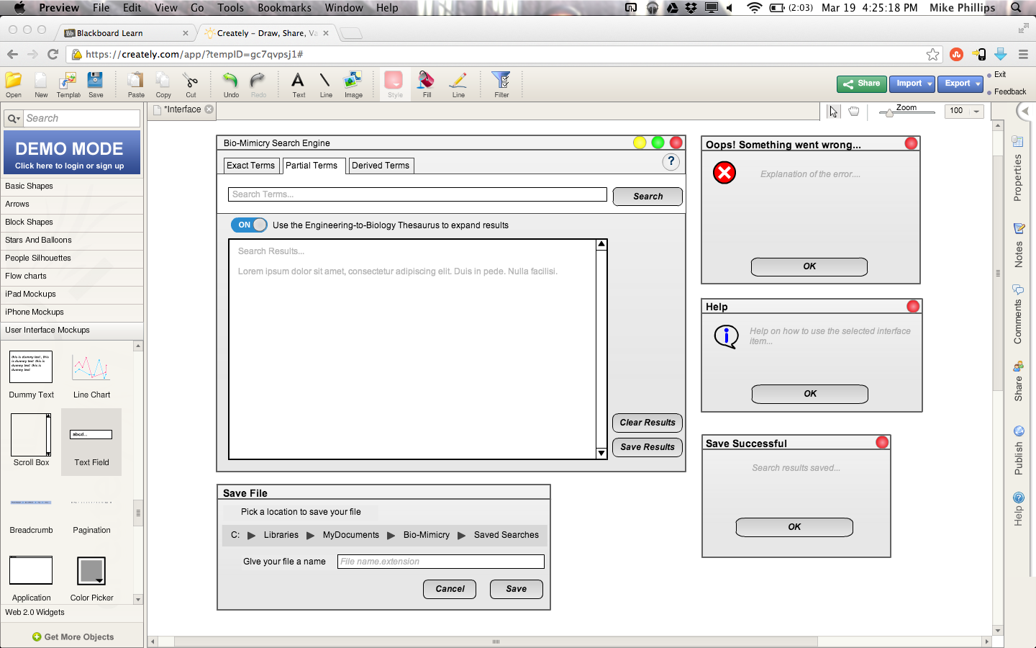

Figure 1. The main screen of the application will present almost the entirety of the functionality. At the top is a label and action buttons to minimize, maximize and close. To the right is also a help button, discussed later. Below that are tabs to select what type of search to perform and inside each is the appropriate search box and a search button. Also below is a button of some kind to allow the user to select the thesaurus functionality. A results box follows along with clear and save buttons.



Figure 2. A sample error box, that could indicate any number of errors the user might encounter.



Figure 3. The help dialogue appears after the user engages the help button then clicks another interface item. This box will then explain the actions and uses of the selected interface item.



Figure 4. The save file dialogue might slide down from the top of the main window and present the user with the option to pick a storage location and give their results file a name, then confirm or discard the save action. A successful save will draw Figure 5; an unsuccessful save will draw an error box.



Figure 5. This dialogue will confirm a successful save of the search results to local (or other selected) storage. In the event of an unsuccessful save, the user will be presented with an error box.